


Functional Specification
Customer Portal – NetSuite Integration with Celigo
(Phase I)

Change Log
DATE | AUTHOR | VERSION | DESCRIPTION
03/28/2024 | Zeeshan Nawaz | 1.0.0 | Outline the functional specifications document for the Customer Portal - NetSuite Integration
04/10/2024 | Zeeshan Nawaz | 1.0.1 | Update points -> 3.1, 3.1.1 & 3.1.4 for clear understanding.
05/1/2024 | Zeeshan Nawaz | 1.0.2 | Remove Fellers(Customer) details, update process of flow 1 and point 5 flowchart diagram.
05/7/2024 | Zeeshan Nawaz | 1.0.3 | Added phase two integration detail on a very high level. See 2.1.1 & 2.1.2
05/29/2024 | Zeeshan Nawaz | 1.0.4 | Added error handling sections for transferring data for both from SFTP/FTP to NetSuite and vice versa. See sections 4.4.

Contents
Contents 3
1. Introduction 5
1.1 Purpose 5
1.2 Scope 5
1.3 Objectives 5
2. Overview of Integration 6
2.1 Description 6
2.1.1 Phase One: Initial Setup 6
2.1.2 Phase Two: Dynamic Flow Management 6
2.2 Integration Components 6
3. Integration Flows 7
3.1 Detailed description of each integration flow: 7
3.1.1 Flow 1: Creating Sales Orders in NetSuite 7
3.1.2 Flow 2: Uploading/Overwrite ordconf.csv file in Customer Portal 8
3.1.3 Flow 3: Upload/Overwrite dalinv.csv in file Customer Portal. 8
3.1.4 Flow 4: Upload/Overwrite custstmt.csv file in Customer Portal. 9
3.1.5 Flow 5: Upload/Overwrite invaval.csv file in Customer Portal. 9
4. Integration requirements 10
4.1 Celigo bundle Installation 10
4.2 Connectivity 10
4.3 Data Mapping 10
4.4 Error Handling 10
4.4.1 Transferring Data from SFTP/FTP Server to NetSuite 11
4.4.2 Transferring NetSuite Data to SFTP/FTP Server by Creating/Overwriting a File 12
4.5 Scheduling 12
4.6 Security 12
5. Integration Flow Diagram 13
6. User Interfaces 14
6.1 Customer Portal (SFTP/FTP) 14
6.2 NetSuite Dashboard 14
7. Assumptions 15
7.1 Pre-conditions 15
7.1.1 Access to Credentials 15
7.1.2 Infrastructure Readiness 15
7.2 Post-conditions 15
7.2.1 Successful Data Sync 15
7.2.2 Error-Free Integration 15
7.2.3 Timely Updates 15
7.2.4 Compliance 15
8. Constraints 16
8.1 Technical 16
8.1.1 Compatibility Issues 16
8.1.2 Data Transfer Limitations 16
8.1.3 API Rate Limits 16
9. Risks and Mitigation Strategies 17
9.1 Data Security Risks 17
9.2 Integration Failures 17
9.3 Data Consistency Risks 17
9.4 Performance Issues 17
9.5 Compliance Risks 17
9.6 Dependency Risks 17
9.7 Training and Documentation Risks 17
10. Conclusion 18
11. Appendices 18
12. Sign-off 19

1. Introduction

1.1 Purpose
The purpose of this document is to outline the functional specifications for the integration between the Customer Portal (SFTP/FTP) and NetSuite using the Celigo.
This document represents information gathered in meetings held with the customer, which enables the Paapri team to map the business requirements to an efficient flow. Once complete, this document will serve as a blueprint for the Paapri team to begin the Integration process.

1.2 Scope
This integration aims to synchronize order data, open orders, open invoices, customer statements, and inventory availability data between the Customer Portal and NetSuite. It involves creating five flows within Celigo Connector to facilitate this synchronization.

1.3 Objectives
- Import Open orders from Grimco, and JDS folders in the Customer Portal to NetSuite as sales orders.
- Create a ordconf.csv file in Celigo by Open orders data from NetSuite and upload/overwrite this file to the Customer Portal.
- Create a dalinv.csv file in Celigo by invoice records data from NetSuite and upload/overwrite this file to the Customer Portal.
- Create a custstmt.csv file in Celigo by customer statement data from NetSuite and upload/overwrite this file to the Customer Portal.
- Create a invaval.csv file in Celigo by inventory availability data from NetSuite and upload/overwrite this file to the Customer Portal.

2. Overview of Integration

2.1 Description
The integration will leverage Celigo to establish a connection between the Customer Portal and NetSuite. It will involve real-time and batch data synchronization to ensure consistency across both platforms. This Integration will be in 2 phases.

2.1.1 Phase One: Initial Setup
In this phase, the integration will focus on establishing connectivity between the Customer Portal (SFTP) and NetSuite using Celigo Connector. The primary objectives include:
- Pushing all existing orders of customers from the Customer Portal to NetSuite.
- Pushing all open orders, open invoices, customer statements, and inventory availability data from NetSuite to the Customer Portal.
This phase aims to lay the foundation for seamless data exchange between the two platforms, ensuring that historical data is synchronized accurately.

2.1.2 Phase Two: Dynamic Flow Management
The second phase of the integration will introduce dynamic flow management capabilities, empowering clients to configure new flows in Celigo for fetching sales order files from individual customer folders and removing existing flows as needed. A comprehensive document will be provided to guide clients through this process.
Key features of Phase Two include:
Dynamic Flow Creation: Clients will be able to add new flows in Celigo to fetch sales order files from specific customer folders on the Customer Portal (SFTP) whenever a new customer is added.
Flow Removal: Clients will have the capability to remove existing flows from Celigo when customers are removed from the Customer Portal or when their order flow requirements change.
This phase emphasizes client autonomy and flexibility, allowing them to adapt the integration to their evolving business needs without extensive external support. By providing clear documentation and generalized instructions, clients can efficiently manage their integration workflows, ensuring continued alignment with their business processes.
Note: This document contains comprehensive information regarding the First Phase of Integration exclusively. Following the completion of the First Phase, a separate document detailing the Second Phase of Integration will be provided.

2.2 Integration Components
- Celigo Integration App
- Customer Portal API
- NetSuite API

3. Integration Flows

3.1 Detailed description of each integration flow:
- Create two connections to the Customer Portal (SFTP Server & FTP Server) within Celigo for executing GET/POST operations with the Customer Portal. This connection shall be identified as the "SFTP Connection" & "FTP Connection" within Celigo.
- Create a connection with NetSuite in Celigo for executing GET/POST operations with the NetSuite. This connection shall be identified as the "NetSuite Connection" within Celigo.

3.1.1 Flow 1: Creating Sales Orders in NetSuite
Objective:
- Retrieve order data from the "Grimco", and "JDS" folders within the Customer Portal and import it into NetSuite by creating sales orders.
Process:
- Use the “SFTP Connection” to initiate the flow for Customer Portal. And use “FTP connection” specifically for accessing JDS folder.
- Monitor the designated files for new order data. These files should be located at `/public_html/public/csvfiles/{Company Name}/{Company Name}_PO_Files/{Name of the files}`. If any files are present, Celigo will generate orders in NetSuite using the data from those files. Retrieve order data files from these company folders "Grimco", and "JDS".
- Convert the incoming data from the Customer Portal, originally in flat CSV format, into a JSON Object format by generating a new Transformation script within Celigo.
- Use the “NetSuite Connection” to connect with NetSuite.
- Part Numbers from these files will be mapped with the NetSuite Item name.
- Import sales orders into the NetSuite. We will use the Customer Portal Customer PO# with NetSuite sales order number for mapping or duplicate checking.
- After importing order data into the NetSuite, Celigo will move those files to a backup location. The path for backup files is `/public_html/public/csvfiles/{Company Name}/{Company Name Initials}POF_Backup.`
- The scheduled time to run these flows should be – every 15 minutes.

Note: We will separate two separate flows for creating sales orders in the NetSuite for all these two different folders - "Grimco", and "JDS".

3.1.2 Flow 2: Uploading/Overwrite ordconf.csv file in Customer Portal
Objective:
- Update the ordconf.csv file in the Customer Portal with open order data from NetSuite.
Process:
- Create a saved search in NetSuite with all the open sales orders and open quotes.
- Use the “NetSuite Connection” to initiate the flow for NetSuite.
- Transform the data into a CSV file with the name – ordconf.csv.
- Use the “SFTP Connection” to create a connection with Customer Portal.
- Upload/Overwrite the existing ordconf.csv file in the Customer Portal with the updated open order data. Path - “/public_html/public/csvfiles”.
- The scheduled time to run these flows should be – every 15 minutes.

3.1.3 Flow 3: Upload/Overwrite dalinv.csv in file Customer Portal.
Objective:
- Update the dalinv.csv file in the Customer Portal with open invoice records from NetSuite.
Process:
- Create a saved search in NetSuite with all the open invoices
- Use the “NetSuite Connection” to initiate the flow for NetSuite.
- Transform the data into a CSV file with the name – dalinv.csv.
- Use the “SFTP Connection” to create a connection with Customer Portal
- Upload/Overwrite the existing dalinv.csv file in the Customer Portal with the updated open invoice file. Path - “/public_html/public/csvfiles”.
- The scheduled time to run these flows should be – daily at 9:30 AM EST.

3.1.4 Flow 4: Upload/Overwrite custstmt.csv file in Customer Portal.
Objective:
- Update the custstmt.csv file in the Customer Portal with customer statement data from NetSuite.
Process:
- Create a saved search in NetSuite on Invoice, customer deposit (On Account), Credit Memos, Payment & Journal record to fetch all the customer statements.
- Use the “NetSuite Connection” to initiate the flow for NetSuite.
- Transform the data into a CSV file with the name – custstmt.csv.
- Use the “SFTP Connection” to create a connection with Customer Portal
- Upload/Overwrite the existing custstmt.csv file in the Customer Portal with the updated customer statement file created in Celigo.
- The scheduled time to run these flows should be – 11:30 PM daily.

3.1.5 Flow 5: Upload/Overwrite invaval.csv file in Customer Portal.
Objective:
- Update the invaval.csv file in the Customer Portal with inventory availability data from NetSuite.
Process:
- Create a saved search in NetSuite with the inventory availability.
- Use the “NetSuite Connection” to initiate the flow for NetSuite.
- Retrieve inventory availability data from NetSuite.
- Transform the data into a CSV file with the name – custstmt.csv.
- Use the “SFTP Connection” to create a connection with Customer Portal
- Upload/Overwrite the existing invaval.csv file in the Customer Portal with the updated inventory availability data.
- The scheduled time to run these flows should be – every 30 minutes.

4. Integration requirements

4.1 Celigo bundle Installation
Need to install a few bundles in NetSuite for Celigo which will add a few fields and scripts in NetSuite that require Celigo to communicate between Celigo and NetSuite.

4.2 Connectivity
Establish secure connections between the Customer Portal (SFTP/FTP server), and NetSuite in Celigo connector.

4.3 Data Mapping
Define clear mapping rules to ensure compatibility between data formats.

4.4 Error Handling
Implement robust error-handling mechanisms to manage exceptions and ensure data integrity.
Note: Refer to this diagram to familiarize yourself with the terms used in our error handling statements.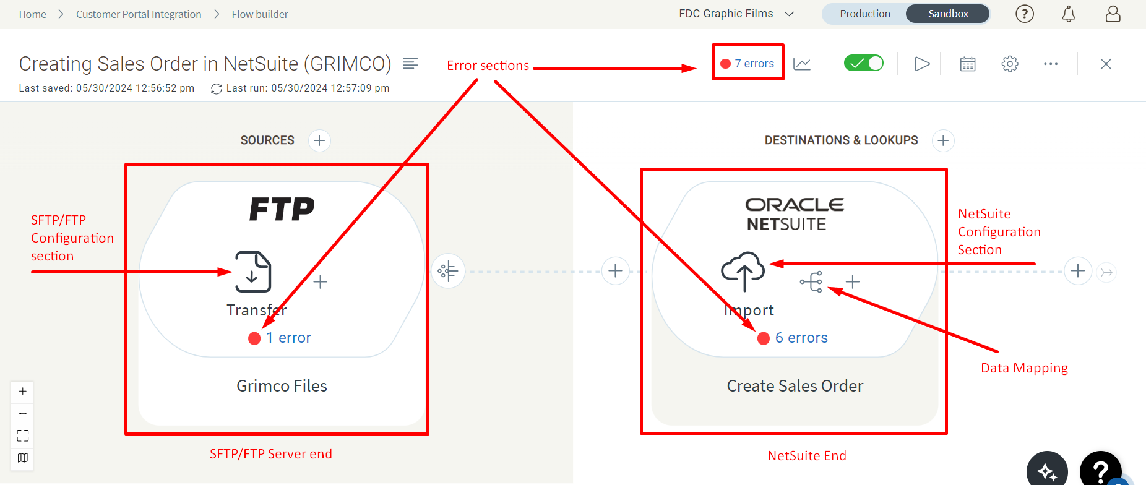

4.4.1 Transferring Data from SFTP/FTP Server to NetSuite

4.4.1.1. Case 1 - File Reading Failure
- Scenario: If reading a file from the SFTP/FTP server fails due to issues such as incorrect data formatting or missing delimiters (e.g., commas or pipes) in the CSV file, Celigo will move the file from the main location to the backup location and notify you via email with an error explanation.
- Action Required:
1. Identify and Retry:
- Go to Celigo and locate the error section where you will find two buttons:
- Retry & Next: Click this button if you don't need to make any changes, such as in the case of an intermittent error.
- Resolve & Next: Click this button to categorize an error as fixed, regardless of any edits or updates, and remove it from the queue.
2. Manual Check and Fix:
- Manually inspect the file which are moved on the backup location, resolve the issues causing the error, and then move the file back to the original location so it can be read by Celigo in the next run.

4.4.1.2 Case 2 - NetSuite Import Failure
- Scenario: If the file is read successfully but there are issues during the NetSuite import process. In this case, file will get transferred from sourced location to backup.
- Action Required:
1. Identify and Retry:
- Go to Celigo and locate the error section where you will find two buttons:
- Retry & Next: Click this button if you don't need to make any changes, such as in the case of an intermittent error.
- Resolve & Next: Click this button to categorize an error as fixed, regardless of any edits or updates, and remove it from the queue.
2. Manual Check and Fix:
- Manually inspect the file which are moved on the backup location, resolve the issues causing the error, and then move the file back to the original location so it can be read by Celigo in the next run.
3. Review Mappings:
- Check the data mappings created in the NetSuite end to ensure they are correctly configured.

4.4.2 Transferring NetSuite Data to SFTP/FTP Server by Creating/Overwriting a File

4.4.2.1. Case 1 - Fetching Failure from NetSuite
- Scenario: If fetching data from the NetSuite create any issue.
- Action Required:
1. Identify and Retry:
- Go to Celigo and locate the error section where you will find two buttons:
- Retry & Next: Click this button if you don't need to make any changes, such as in the case of an intermittent error.
- Resolve & Next: Click this button to categorize an error as fixed, regardless of any edits or updates, and remove it from the queue.
2. Error Message Review:
- Review the error messages received via email or in the Celigo error section. Based on the error message, check and correct all configurations in NetSuite end.
3. Review Saved Searches:
- Review any saved searches in NetSuite used for fetching data to ensure they are correctly configured.

4.4.2.2 Case 2 - Uploading/Overwriting File Failure to SFTP/FTP Server
- Scenario: If the data is fetch correctly from NetSuite but an error occurs while uploading/overwriting files on the SFTP/FTP server.
- Action Required:
1. Identify and Retry:
- Go to Celigo and locate the error section where you will find two buttons:
- Retry & Next: Click this button if you don't need to make any changes, such as in the case of an intermittent error.
- Resolve & Next: Click this button to categorize an error as fixed, regardless of any edits or updates, and remove it from the queue.
2. Configuration Check:
- Verify all configurations on the SFTP/FTP server, including directory paths, file names, file types, and delimiters if using CSV files.
Note: By following these error handling procedures, you can effectively manage and resolve any issues that arise during the data transfer processes between SFTP/FTP servers and NetSuite using Celigo.

4.5 Scheduling
Configure automated scheduling for the execution of integration flows.

4.6 Security
Implement measures to ensure data confidentiality and access control.

5. Integration Flow Diagram


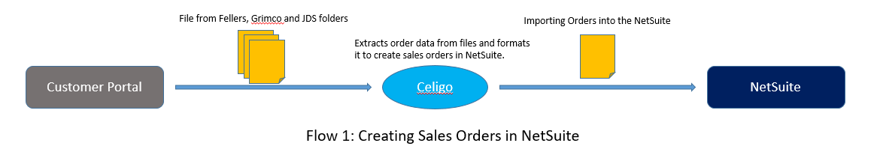

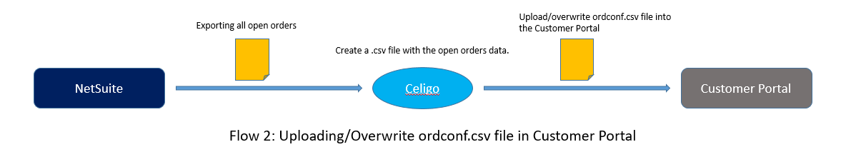

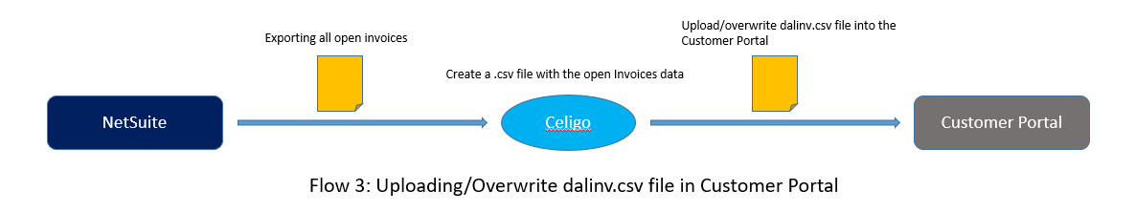

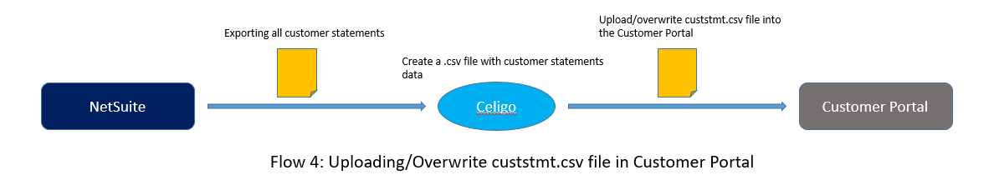

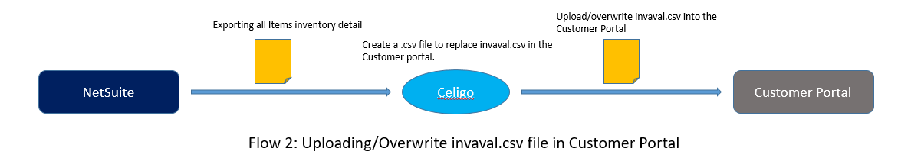

6. User Interfaces

6.1 Customer Portal (SFTP/FTP)
- Provide access to specific folders and files for data exchange with NetSuite.
- Securely manage credentials and access permissions.

6.2 NetSuite Dashboard
- Enable administrators to monitor integration activities and data flow.
- Provide a saved search for data reconciliation and troubleshooting.

7. Assumptions

7.1 Pre-conditions

7.1.1 Access to Credentials
Users involved in the integration process, such as system administrators or developers, are assumed to have access to the necessary credentials for accessing the Customer Portal (SFTP/FTP) and NetSuite. This involves having valid usernames, passwords, and any required authentication tokens or keys.

7.1.2 Infrastructure Readiness
Both the Customer Portal (SFTP/FTP) and NetSuite are assumed to have the necessary infrastructure in place to support integration activities. This includes having sufficient server capacity, storage space, and network bandwidth to handle data transfer requirements

7.2 Post-conditions

7.2.1 Successful Data Sync
It's assumed that data synchronization between the Customer Portal and NetSuite will be successful, with accurate and consistent data transferred between the systems. This ensures that orders, invoices, payments, and other relevant information are updated and reflected accurately on both platforms.

7.2.2 Error-Free Integration
The integration solution is assumed to run without errors or interruptions, with robust error-handling mechanisms in place to address any issues that may arise during data transfer. This ensures smooth operation and minimal disruption to business processes.

7.2.3 Timely Updates
Regular updates and maintenance activities are assumed to be performed on the integration solution to address any bugs, security vulnerabilities, or performance issues. This ensures the continued reliability and effectiveness of the integration over time.

7.2.4 Compliance
The integration solution is assumed to comply with relevant data privacy regulations, such as GDPR or CCPA, ensuring that customer data is handled securely and in accordance with legal requirements. This involves implementing appropriate data protection measures and obtaining necessary consent for data processing activities

8. Constraints

8.1 Technical

8.1.1 Compatibility Issues
There might be compatibility challenges between different versions of Celigo Connector, the Customer Portal (SFTP/FTP), and NetSuite APIs. Upgrades or changes in any of these components may lead to integration issues.

8.1.2 Data Transfer Limitations
The SFTP/FTP protocol used by the Customer Portal may have limitations on data transfer speed or file size. This could affect the efficiency of data synchronization, especially when dealing with large volumes of data.

8.1.3 API Rate Limits
NetSuite may impose rate limits on API calls, which could affect the frequency or volume of data that can be transferred between the systems within a given time frame. This constraint needs to be considered while designing the integration workflows.

9. Risks and Mitigation Strategies

9.1 Data Security Risks
- Risk: Unauthorized access during data transfer.
- Mitigation: Encrypt data during transmission, and regularly update security measures.

9.2 Integration Failures
- Risk: Technical issues or API changes.
- Mitigation: Thorough testing, automated monitoring, and prompt resolution with Celigo support.

9.3 Data Consistency Risks
- Risk: Inconsistencies in synchronization.
- Mitigation: Implement data validation checks, rollback mechanisms, and regular audits.

9.4 Performance Issues
- Risk: Bottlenecks during high-volume transfers.
- Mitigation: Optimize workflows, implement caching, monitor, and scale resources.

9.5 Compliance Risks
- Risk: Non-compliance with regulations.
- Mitigation: Ensure data handling aligns with regulations, and update policies regularly.

9.6 Dependency Risks
- Risk: Dependency on third-party services.
- Mitigation: Diversify dependencies, monitor SLAs, and maintain contingency plans.

9.7 Training and Documentation Risks
- Risk: Insufficient training and documentation.
- Mitigation: Provide comprehensive training, and update documentation regularly.

10. Conclusion
This functional specification document provides a detailed blueprint for integrating the Customer Portal with NetSuite using Celigo. Feedback and review from stakeholders are essential to ensure the successful implementation of the integration.

11. Appendices
Additional supporting documentation or references can be included here for further information.

Note:
This document serves as a comprehensive guide for the Customer Portal - NetSuite integration project, outlining the requirements, objectives, and processes involved. It will be used as a reference throughout the implementation phase to ensure the successful execution of the integration.

12. Sign-off
CUSTOMER | PAAPRI CLOUD TECHNOLOGIES
SIGNATURE: | SIGNATURE:
PRINT NAME: | PRINT NAME:
TITLE: | TITLE:
COMPANY NAME: | COMPANY NAME:
DATE: | DATE:

